Game Design Document

Fill up the following document

1. Write the title of your project.

Multiplayer Sounding Tiles

1. What is the goal of the game?

The players need to earn more points and touch all the stars.

1. Write a brief story of your game.

There will be a form and when two player joins,the game starts.

There will be many tiles and coins and the players should touch those tiles and coins. The player who has more points will win the game.

There will be some stars and stars bar and if the player touches the stars,the stars bar will increase and if they didn’t touch them it will decrease and once it is zero,the player will lose the game.

There will be a song also in this game.

1. Which are the playing characters of this game?

* Playing characters are the ones who respond to the user based on the input from the user.
* Cars, monkeys, dinos, wizards, etc., are the playing characters in the game.

|  |  |  |
| --- | --- | --- |
| Number | Character Name | What can this character do? |
| 1 | No playing characters |  |
| 2 |  |  |
| 3 |  |  |
| 4 |  |  |
| 5 |  |  |
| 6 |  |  |
| 7 |  |  |
| 8 |  |  |

1. Which are the Non-Playing Characters of this game?

* Non-Playing characters are the ones that don't have an action or behavior when the user interacts with the game.
* Hurdles, stones, bananas, coins, etc., are non-playing characters in the game.

|  |  |  |
| --- | --- | --- |
| Number | Character Name | What can this character do? |
| 1 | Tiles | They will increase the score of the player. |
| 2 | Coins | They will also increase the score. |
| 3 | Stars | If they didn’t touch them the bar will decrease and they will lose the game |
| 4 |  |  |
| 5 |  |  |
| 6 |  |  |
| 7 |  |  |
| 8 |  |  |

Draw your imagination of this game. What does this game look like?

* Draw the game either on your computer or on paper.
* Add images of the game scenes to show each of the playing and non-playing characters at least once.

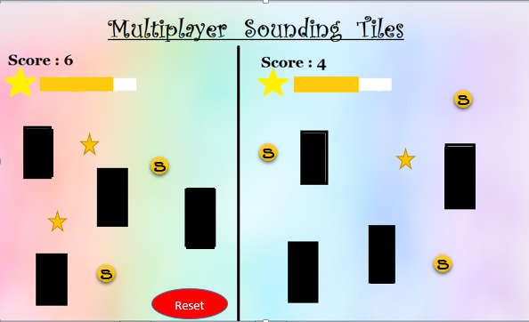

How do you plan to make your game engaging?

By adding songs and by making the game colorful.